Our India Tours and Travel Specialists are passionate about delivering premium travel experiences to India, Sri Lanka, Nepal, Bhutan and the Maldives.
Clients often ask about what to see and do that offers the very best experience within the area they are heading too.
This week we showcase 6 "Best of.." recommendations from our India Travel Specialists team. Discover Northern India, Southern India and everything in-between.
Remember, our friendly and experienced professionals are more than happy to assist you in crafting a specialist itinerary that your clients will rave about for years to come.
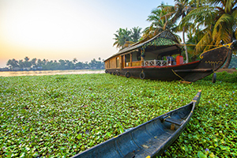
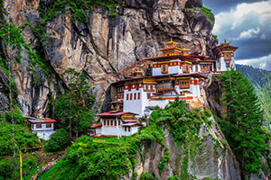

 | Best of Bhutan  Regarded as one of the last Shangri-Las in the Himalayas due mainly to its remoteness; Bhutan lies in a relatively unexplored pocket of Asia.  To preserve its natural beauty, Bhutan has heavy restrictions in place regarding the number of travellers visiting this country.  Join this exclusive Best of Bhutan tour and discover the spectacular world of the Himalayan Mountains and forested hills, where magnificent fortresses still command the hilltops.  7 Days/6 Nights per person twin share ..  From Low season...  Standard $2,450 / Luxury $4,985  From High season...  Standard $2,810 / Luxury $6,290  Price Includes:  - 6 nights accommodation on a twin share basis  - Meals as indicated (B, L, D)  - Private transfers and sightseeing as per itinerary  - Services of an accompanying English speaking guide from arrival till departure  - Entrance fees – for single visit only  - Government royalty and taxes  - Bhutan Visa fee  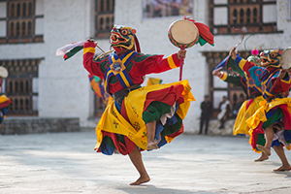  "Off the beaten track, it's as if you have stepped back in time. A true cultural delight."  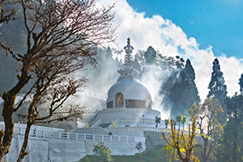 | Best of Kerala  Kerala is one of the most idyllic states of India. Flanked by the Arabian Sea in the west and mountain ranges in the east.  Rich in cultural heritage and known for its beautiful beaches as well as scenic backwaters, Kerala provides a beautiful getaway.  From wildlife sanctuaries and proudly distinctive cuisine, to authentic ayurveda, as well as its many dance forms; Kerala is a delightful and unique Indian holiday experience.  11 Days/10 Nights per person twin share from. Superior: $1,560 / Luxury: $2,475  Price Includes:  - 10 nights twin share accommodation with breakfast daily  - All meals whilst on-board the houseboat  - All sightseeing, excursions and transfers using an AC Vehicle  - Services of local English speaking guides  - Entrance fee at monuments  - Kathakali dance show in Cochin  - Plantation visit in Munnar  - Boat ride at Periyar National Park  - Other inclusions as per itinerary  - Tata Tea Museum, Munnar  - All current applicable taxes  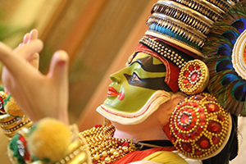  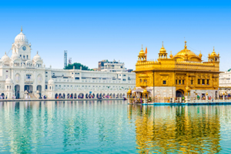  "If offers a wide variety of experiences showcasing culture, landscapes, wildlife and history."
 | Best of North East India  Beginning with a visit to Kolkata (Calcutta), before heading to Darjeeling; known for the tea of the same name, situated near Mt. Kanchenjunga and the great Eastern Himalayas.  This 14 day tour also visits Pelling and Gangtok in the state of Sikkim, known for its colonial mansions, its churches and a variety of Buddhist and Hindu temples.  14 Days/13 Nights per person twin share from..  Superior: $4,470  Luxury: $4,720  Price Includes:  - 13 nights accommodation  - All meals as indicated (B, L, D)  - All sightseeing, excursions & transfers  - Services of English speaking guide  - Toy train ticket in Darjeeling  - Economy airfare Kolkata–Bagdogra, Bagdorgra–Guwahati and Dimapur– Kolkata  - 3 Jeep Safaris in Kazriranga NP  - Entrance fees at Monuments  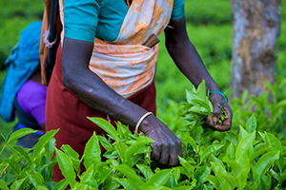  "The addition of the Jeep Safari Game Drives at Kaziranga NP sets this tour apart from the rest."  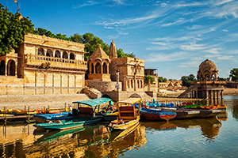 | Best of Amritsar & Himachel  This tour starts in Delhi, then heads to the Holy City of Amritsar, home of the Golden Temple, that has more visitors than the Taj Mahal.  Visit Palampur, the tea capital of India as well as Dharamshala, with its Buddhist temples and monasteries. The tour continues on through the foothills of the Himalayas to Shimla; the summer capital of “British India” before heading back to Delhi.  10 Days/9 Nights per person twin share from...  Superior: $2,250  Luxury: $2,950  Price Includes:  - 9 nights twin share accommodation with breakfast daily  - All sightseeing, excursions & transfers using air-conditioned vehicles  - Entrance fees at monuments  - Services of local English speaking guides  - 2 hour toy train ride from Shimla to Kandhagath during day tour  - All current applicable taxes  - Other inclusions as per itinerary  - AC Chair Car Train Tickets  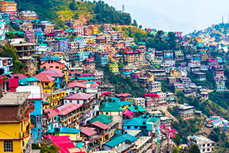  "Offers a wonderful combination of both city and rural, culture and history."  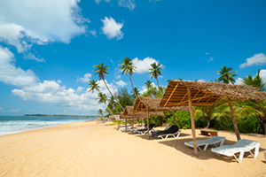

 | Best of Rajasthan  Rajasthan is one of India’s most visited regions, famous for its rich cultural heritage along with spectacular forts and monuments.  This 10 day tour covers all the major attractions in Rajasthan; including the Taj Mahal, Amber Fort, Hawa Mahal (Palace of Winds), as well as the City Palace and more.  This journey takes you deep into Rajasthan’s diversity where you will see some of India’s most breathtaking scenery and sites.  10 Days/9 Nights from..  Superior: $1,920 / Luxury: $5,450  *Not valid during Pushkar Fair 28 Oct – 4 Nov 2019  Price Includes:  - 9 nights twin share accommodation with breakfast daily  - All sightseeing, excursions & transfers using an AC Vehicle  - Services of English speaking guides  - Jodhpur village – cultural tour  - Boat ride in Udaipur  - Economy class airfare from Udaipur–Delhi  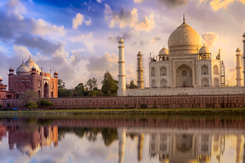  - Entrance fees at Monuments  "It is a tour that offers unparalleled insights into this cultural mecca delivering scenery and sights that are equally as impressive." | Best of Sri Lanka  This tour visits the most popular cities in Sri Lanka. It is an excellent way to get an overview of the culture, history and nature of this fascinating island.  The tour covers Sri Lanka’s most famous tourist attractions including the Pinnawala Elephant Orphanage as well as the Sigiriya Rock Fortress.  Visit the Temple of the Sacred Tooth Relic, tea plantations and many more places of interest.  8 Days/7 Nights from...  From Low season...  Standard $1,625 / Luxury $1,735  From High season...  Standard $1,820 / Luxury $1,935  Price Includes:  - 7 nights accommodation on a twin share basis with breakfast daily  - Transportation by air-conditioned vehicle  - Entrance fees to monuments as per itinerary  - Service of an English Speaking driver/guide  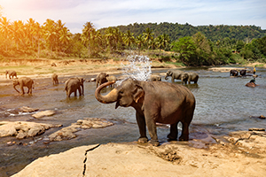  ....  "An excellent overview of Sri Lankas very best."

